
Graphical Password Authentication

MAJOR PROJECT SYNOPSIS

of

BACHELOR OF TECHNOLOGY

in

COMPUTER SCIENCE & ENGINEERING

by

Varun Pawar | Varun Dev | Mayank Chaudhary
Enrollment No: | Enrollment No: | Enrollment No:
10614802718 | 10514802718 | 06314802718

Guided by

Mr. Deepak Gupta

DEPARTMENT OF COMPUTER SCIENCE & ENGINEERING

MAHARAJA AGRASEN INSTITUTE OF TECHNOLOGY (AFFILIATED TO GURU GOBIND SINGH INDRAPRASTHA UNIVERSITY, DELHI)

(Session 2021-2022)
CONTENT OF THE TABLE

ABSTRACT……………………………………………………………………. 3

ACKNOWLEDGEMENT……………………………………………………. 4

CHAPTERS -

- INTRODUCTION. …………………………………………………………….. 6

- METHODOLOGY & ALGORITMS …………………………………………..7

- OBJECTIVE OF THE PROJECT ………………………………………….. 11

- TERMINOLOGIES AND DEFINITIONS ………………………………..... 12

- RESULTS OF PROJECT………………………………………………………17

- CONCLUSION ……………………………………………………………… 18

- REFERENCES ………………………………………………………………. 19

PROOF OF RESEARCH PAPER PUBLISHING …………………………… 33

ABSTRACT

Background: Passwords are ubiquitous today on any platform, on possibly any website. But to remember so difficult passwords and that too on numerous websites seems daunting and therefore you can devise a project illustrating graphical password strategy. This will allow the user to set passwords in the form of graphical presentation in a certain pattern and later use that pattern to login o the system.

Remembering numerous passwords from various different sites can be difficult for a user. So to provide some flexibility we can provide users a graphical password authentication system where instead of creating a password a user has to select graphical objects in a particular order to keep it as their password.

In this method, the user is required to select some images (let’s say different chocolates) in a specific pattern (for example dairy milk is followed by 5 stars which is in turn followed by KitKat and so on). Next time the user tries to log in, the images would have been shuffled, but the user will be required to follow the same pattern which was used initially. Every time the user will have to use the same sequence while the images are placed in different ways. This type of authentication is difficult to break since neither brute force nor dictionary attacks could breach it. We need techniques that can be easily implemented and provide better results to this process

1.1 INTRODUCTION

A Graphical Password Authentication system is an authentication system that uses some combination of graphical images replacing the regular passwords. Graphical passwords may offer better security than text-based passwords because most of the people use regular, popular passwords everywhere and are prone to social engineering attacks. So graphical passwords can put stop to many attacks of this kind.

Resistance to Popular Attacks

- Bruteforce

After reaching max tries, the user will be notified via message through email. And the further authentication through the generic URL/website is disabled for that user account, instead, they have to use the link that will be sent by the company in the notification email. This also lets the legitimate user know about the adversary.

- Shoulder Surfing

Shoulder surfing is a type of social engineering technique used to obtain information such as personal identification numbers (PINs), passwords and other confidential data by looking over the victim's shoulder. The system we adopt is similar to the Phone pattern system. The pattern is invisible on the screen when the users draw it. This makes it incredibly tough for the adversary to see the images on the grid that the user clicks.

- Spyware

Graphical password systems resist spyware more easily than regular passwords. Key-loggers secretly capture keystrokes and transfer, but if the spyware wants to track the mouse movements, it can be tracked, but the adversary wouldn’t know which part of the mouse event is actually the graphical password. The timeline vs mouse-event graph is too difficult to get the pattern

- Hidden Camera

There will be a camera in front of the user which identifies a face while authentication i.e., the number of pixels the face occupies should be 80-90% of the total pixels in the current frame and if this condition is not satisfied then the screen does not show the graphical password. It alerts the user to cover the screen with a proper posture. But this will be a costly operation.

- Phishing

Since the adversary is made to believe that the password is a set of images, it’s not possible to make a fake page, since the adversary thinks he doesn’t know the images. Moreover, we restrict the user to one attempt and suggest the user to give a fake password every time so that he triggers the server to send and URL in email so that he can log in through the legitimate login page, and the adversary cannot send the URL to users from a legitimate server. However, when the adversary knows the technique this attack might be still possible.\
1.2 OBJECTIVE

- The main objective is to make the graphical password for the user so that they do not need to remember the whole password differently for different website , All the user needs to remember is the pattern of selection of ease rememberable images due to which it wil become very easy of the user to remember the password

- Moreover the pattern could be implemented for different login platforms which could solve the problem of remembering different passwords and breaking a continuous cycle of forgetting & reseting password which could be frustrating as well as unsecure

- This password cannot be hacked or traced by any means like brute force, phishing etc , since the password is governed by the pattern of selection selected by user so even if the hacker sees the password , next time the images will be changed set aside the pattern remains same , so the hacker won’t be able to derive the password even after seeing it .

1.3 FEASIBILITY STUDY

1.3.1 Technical feasibility

- This password cannot be hacked or traced by any means like brute force, phishing etc , since the password is governed by the pattern of selection selected by user so even if the hacker sees the password , next time the images will be changed set aside the pattern remains same , so the hacker won’t be able to derive the password even after seeing it .
moreover taking the data in account derived from the packets by exploiting vulnerability , each selection key is encoded & will change after the several second of time making it impossible for the hacker to intercept any information

1.3.2 Economic feasibility

The project is economically feasible as the cost of the project is involved in the hosting of the project on the website where user can use it also it also require the database management system which can hold the use and the image and user data for the authentication . As the data samples increases, which consume more time and processing power. In that case better processor might be needed.
but taking in account the security, sustainability, & abundance in lossed of accounts, logins
& theft every year , the product comes out to be the most efficient system designated to make the password protection better & sustainable

1.3.3 Operational feasibility

The project is operationally feasible as the user having basic knowledge about computer and Internet. Also we are giving the instructions to use the graphical password authenticator.
1.4 METHODOLOGY

We use the hash mapping for the for authenticator and some encryption algo to encrypt the password that user uses. Also some of the feature that we use minimize the size of the data can be used efficiently.

Moreover synchronous working of the technologies are used in a constructive way to pave out the way of working some of these technologies & algorithms are :-

- Hash Salt

Salted secured hash algorithm helps protect password hashes against dictionary attacks by introducing additional randomness. Password hash salting is when random data – a salt – is used as an additional input to a hash function that hashes a password. The goal of salting is to defend against dictionary attacks or attacks against hashed passwords using a rainbow table.
To salt a password hash, a new salt is randomly generated for each password. The salt and the password are concatenated and then processed with a cryptographic hash function. The resulting output (but not the original password) is stored with the salt in a database.
Since salts do not have to be memorized by humans they can make the size of the rainbow table required for a successful attack prohibitively large. Since salts are different in each password, they also protect commonly used passwords or those who use the same password on several sites, by making all salted hash instances for the same password different from each other

- Encryption

In cryptography, encryption is the process of encoding information. This process converts the original representation of the information, known as plaintext, into an alternative form known as ciphertext. Ideally, only authorized parties can decipher a ciphertext back to plaintext and access the original information. Encryption does not itself prevent interference but denies the intelligible content to a would-be interceptor.
For technical reasons, an encryption scheme usually uses a pseudo-random encryption key generated by an algorithm. It is possible to decrypt the message without possessing the key but, for a well-designed encryption scheme, considerable computational resources and skills are required. An authorized recipient can easily decrypt the message with the key provided by the originator to recipients but not to unauthorized users.
Historically, various forms of encryption have been used to aid in cryptography. Early encryption techniques were often used in military messaging. Since then, new techniques have emerged and become commonplace in all areas of modern computing.[1] Modern encryption schemes use the concepts of public-key and symmetric-key.[1] Modern encryption techniques ensure security because modern computers are inefficient at cracking the encryption.

CyberSecurity

Computer security, cybersecurity (cyber security), or information technology security (IT security) is the protection of computer systems and networks from information disclosure, theft of, or damage to their hardware, software, or electronic data, as well as from the disruption or misdirection of the services they provide.[1]
The field has become significant due to the expanded reliance on computer systems, the Internet,[2] and wireless network standards such as Bluetooth and Wi-Fi, and due to the growth of "smart" devices, including smartphones, televisions, and the various devices that constitute the Internet of things (IoT). Cybersecurity is also one of the significant challenges in the contemporary world, due to its complexity, both in terms of political usage and technology. Its primary goal is to ensure the system's dependability, integrity, and data privacy.

Api authorization
APIs use authorization to ensure that client requests access data securely. This can involve authenticating the sender of a request and confirming that they have permission to access or manipulate the relevant data. If you're building an API, you can choose from a variety of auth models. If you're integrating a third-party API, the required authorization will be specified by the API provider.
You can pass auth details along with any request you send in Postman. Auth data can be included in the header, body, or as parameters to a request. If you enter your auth details in the Authorization tab, Postman will automatically populate the relevant parts of the request for your chosen auth type. You can use variables and collections to define authorization details more safely and efficiently, enabling you to reuse the same information in multiple places.

Django Rest Frame Work
The Django REST Framework (DRF) is a package built on top of Django to create web APIs. One of the most remarkable features of Django is its Object Relational Mapper (ORM) which facilitates interaction with the database in a Pythonic way.
However, we can not send Python objects over a network, and hence need a mechanism to translate Django models in other formats like JSON, XML, and vice-versa. This sometimes challenging process, also called serialization, is made super easy with the Django REST Framework

Django JWT authentication

Django comes with a session-based authentication system that works out of the box. It includes all of the models, views, and templates you need to let users log in and create a new account. Here's the rub though: Django's authentication only works with the traditional HTML request-response cycle.
What do we mean by "the traditional HTML request-response cycle"? Historically, when a user wanted to perform some action (such as creating a new account), the user would fill out a form in their web browser. When they clicked the "Submit" button, the browser would make a request — which included the data the user had typed into the registration form — to the server, the server would process that request, and it would respond with HTML or redirect the browser to a new page. This is what we mean when we talk about doing a "full page refresh."

Cross-Origin Resource Sharing (CORS)

Cross-Origin Resource Sharing (CORS) is an HTTP-header based mechanism that allows a server to indicate any origins (domain, scheme, or port) other than its own from which a browser should permit loading resources. CORS also relies on a mechanism by which browsers make a "preflight" request to the server hosting the cross-origin resource, in order to check that the server will permit the actual request. In that preflight, the browser sends headers that indicate the HTTP method and headers that will be used in the actual request.

1.4.1 SOFTWARE/HARDWARE REQUIREMENTS

- Any updated web-browser

- CPU (Pentium or higher with 1.8 GHz speed or higher)

- Stable internet connection (>2Mbps)

1.4.2 BENEFITS TO THE SOCIETY

This type of authentication is difficult to break since neither brute force nor dictionary attacks could breach it. We need techniques that can be easily implemented and provide better results to this process.

1.5 RESULT

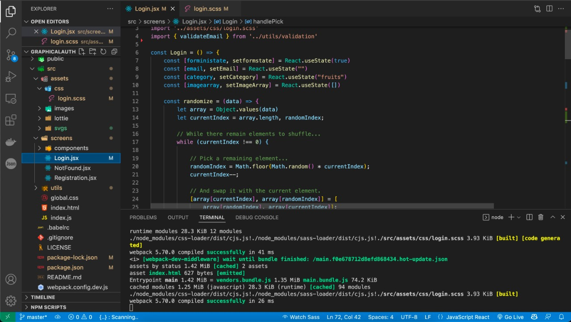
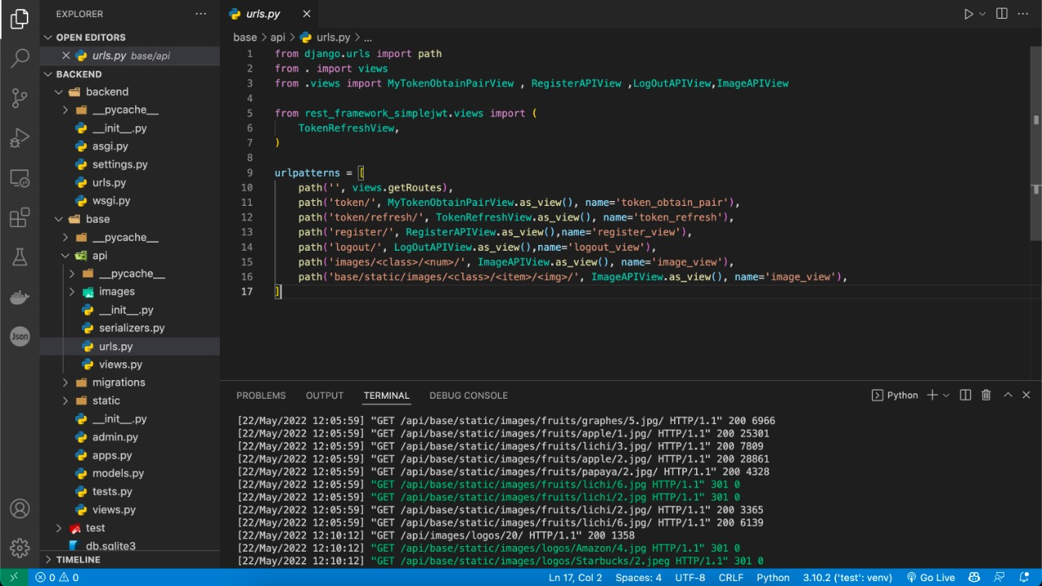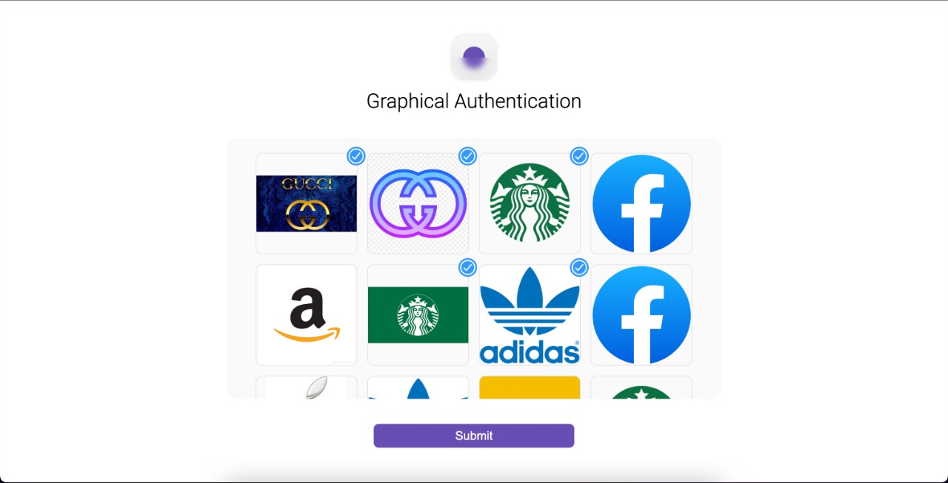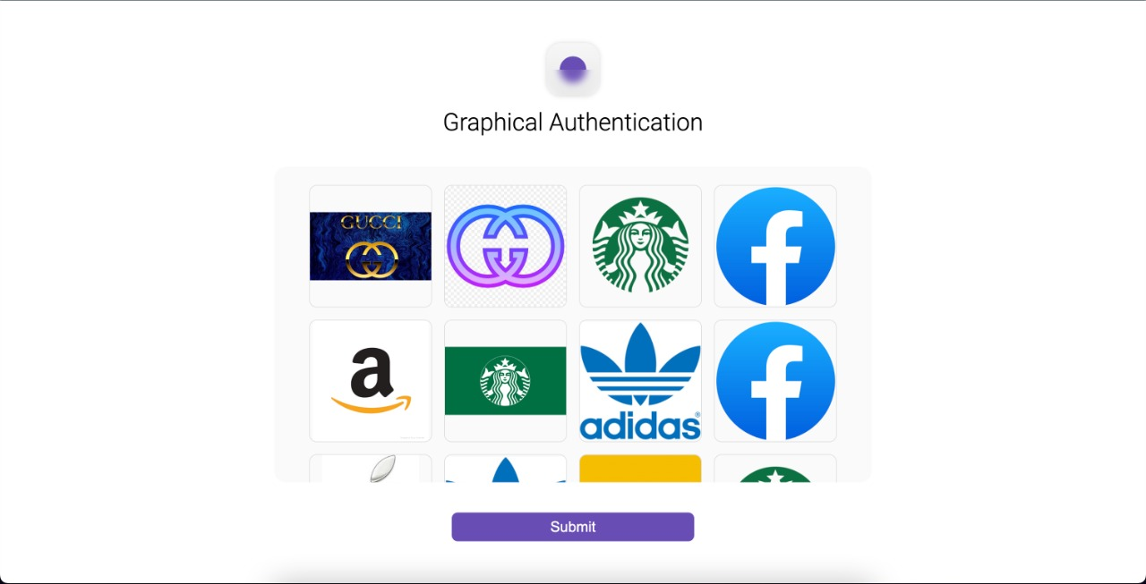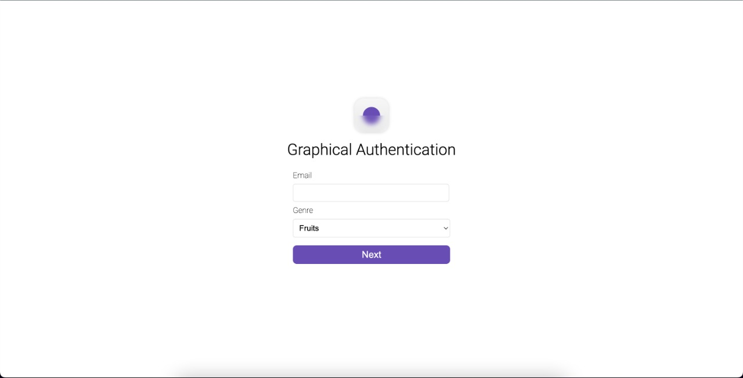

1.6 REFRENFCES

- Bhandari S (1997) Engineering rock blasting operations. A A Balkema, Rotterdam, p 388

- Singh TN, Singh V (2005) An intelligent approach to prediction and control ground vibration in mines. Geotech Geol Eng

- Jahed Armaghani D, Hajihassani M, Marto A et al (2015) Prediction of blast-induced air overpressure: a hybrid AI-based predictive model. Environ Monit Assess. https://doi.org/10.1007/s1066

1-015-4895-6

- Koopialipoor M, Fallah A, Armaghani DJ et al (2018) Three

hybrid intelligent models in estimating fyrock distance resulting from blasting. Eng Comput.

https://doi.org/10.1007/s0036

6-018-0596-4

